[1]

Implementation of wind turbines on Scotland IslandImplemet

L. Tran, *University of Technology Sydney,* Renewable Energy Systems

*Abstract* – Implementating a renewable energy system required several steps, involving discussions between advantages and disadvantages. First, a place and a type of energy has to be chosen. In addition, the system specification, topology and components must be researched and discussed. Finally, an evaluation of the system performance is needed to complete the project and asses its economical and practical feasibility.

*Index Terms*—Isolated Island, Research, Renewable Energy System, Scotland Island, Wind Energy.

# Introduction

As renewable energy systems reveals more and more advantages to the world and its bright future, its popularity has significantly risen. The implementation of renewable energy systems for isolated island was discussed in this report, using evidence of its obvious economic and environmental advantages.

# Identify A Place and Renewable Energy Source(s)

Several questions needed to be answered in order to find a suitable place and renewable energy source(s) that satisfies and make the project viable. First, who will be in need of renewable energy, and will the advantages outweigh the disadvantages of exploring those energy? One answer came to mind: renewable energy source(s) implemented in small or private islands. The system would be most suitable for small islands such as Scotland Island in Sydney that has a diameter of around 1km. My conjecture has proven to be accurate as several articles from different sources has confirmed my claim. “With rising oil prices, fuel import bills now represent up to 20 percent of annual imports of 34 of the 38 small islands developing states (SIDS)” [1], claims Vanya Walker-Leigh. In fact, the biggest expenses of those islands are importing all kinds of materials. Although it will stop or reduce the amount of fuel imported, setting up and importing the materials for renewable energy system will be costly. It will however save the island money as well as contributing to a clean environment and less pollution, over time. The scenery of those small islands also shouldn’t be affected by the implementation of non-eco-friendly energy source infrastructure. In fact, the implementation of renewable energy systems will reflect a brighter future and will not affect the ecosystem on and around the islands. Furthermore, the high price of importing fuel for electricity uses makes the use of renewable energy system cost competitive. The wide variety of renewable energy systems made the choice of energy difficult. While wave & tidal, and hydroelectric were some choices that came to mind, I have decided to give up on them as views and scenery might be affected and won’t be a first choice for inhabitants. On the other hand, given how common solar energy is used, I believe that it is one of the first choice. As more and more people choose to install solar panels on their roof for personal use, people should be more accepting towards those changes in scenery. Another energy chosen for the project is wind energy. The Danish island of Samsø was the first island to go from fossil fuel dependent to 100% renewable with wind energy. On top of that, coastal areas are suitable as it is windier there because of the sudden change in the atmospheric pressure. In fact, “there is an enormous amount of energy to be harvested from wind” [2]. claims Roger Rassool, a particle physicist at the University of Melbourne. In terms of efficiency, “The most efficient forms of renewable energy geothermal, solar, wind, hydroelectricity and biomass” [3]. Although both solar and wind energy are efficient, I have decided to pursue the project with a wind energy system. The location chosen for this project is Scotland Island, a small island located in Northern Beaches, NSW.

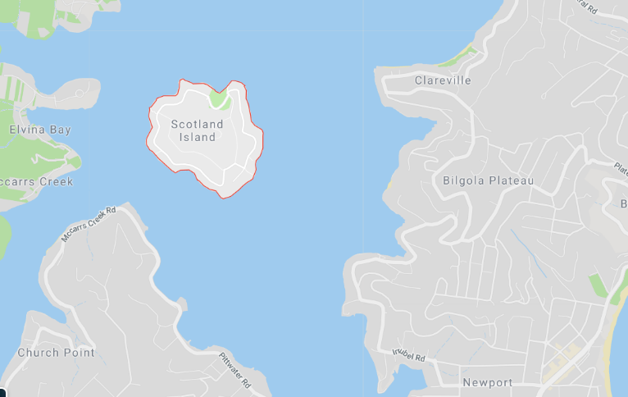

*Figure 1 – Scotland Island (Source: Google Maps)*

# System Specifications

The system used will need to satisfy several specifications. Firstly, the aim of this renewable energy system generation will complement other sources of electricity such as fuel, which is very common to use on islands. It is aimed to provide electricity for one household, acting like a residential generator. Furthermore, it will considerably reduce the use of non-renewable supply of materials and therefore contribute to the reduction of importing those materials. Choosing to complement electricity while not going fully renewable has its advantages. In fact, if a storm is to break own and destroys the newly installed infrastructure, other energy systems such as solar or non-renewable type of system can act as a backup generator in case of emergencies. According to Ausgrid, Daily use of electricity in the Northern Beaches amounts to 16.4 KWh/day. For a whole year, a household in Scotland Island will use around 5,986 KWh/year. In turn, Scotland Island will use around 2,095,100 KWh/year. A large amount of the demand has to be filled with renewable energy systems and the appropriate infrastructure has to be built.

From the wind forecast in Australia, the wind speed for 2019 on Scotland Island has an average of 14.7 km/h.

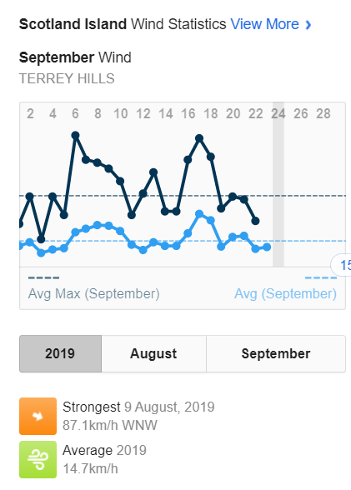

*Figure 2 – Average Wind Speed (Source:* [https://wind.willyweather.com.au](https://wind.willyweather.com.au/))

According to the Danish Wind Industry Association, “the average wind speeds are often available from meteorological observations are measured at a height of 10 meters” [4]. The highest point on Scotland Island reaches 100 meters over sea level, making the location suitable to implement the system. Using their wind calculator, the average wind speed at a height of 100 meters will be 17.83 km/h, or 4.95 m/s.

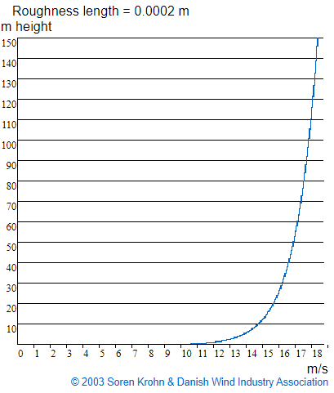

*Figure 3 – Average Wind Speed by height*

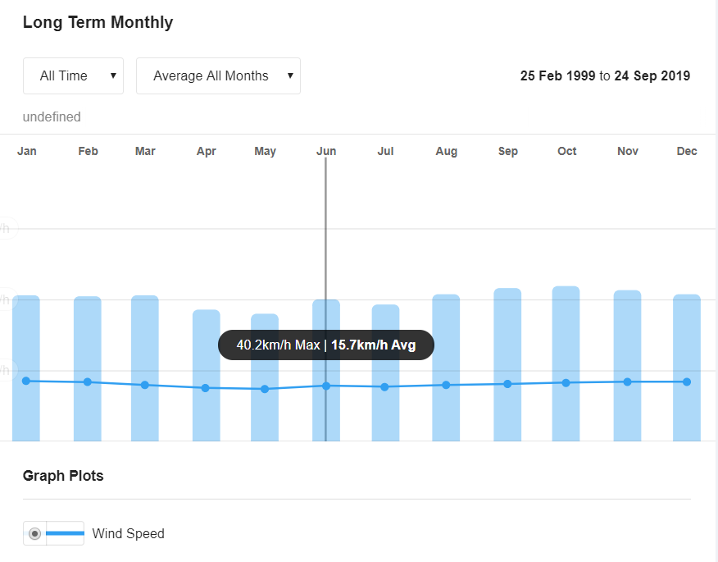

*Figure 4 – Average wind speed monthly*

From the graph above, it is found that the wind resources since 1999 per month is relatively constant, with an average of 15.7 km/h. Although maximum conversion rate is reached when the wind speed is between 10 and 15 m/s, the wind speed will change over time, making the average not as accurate.

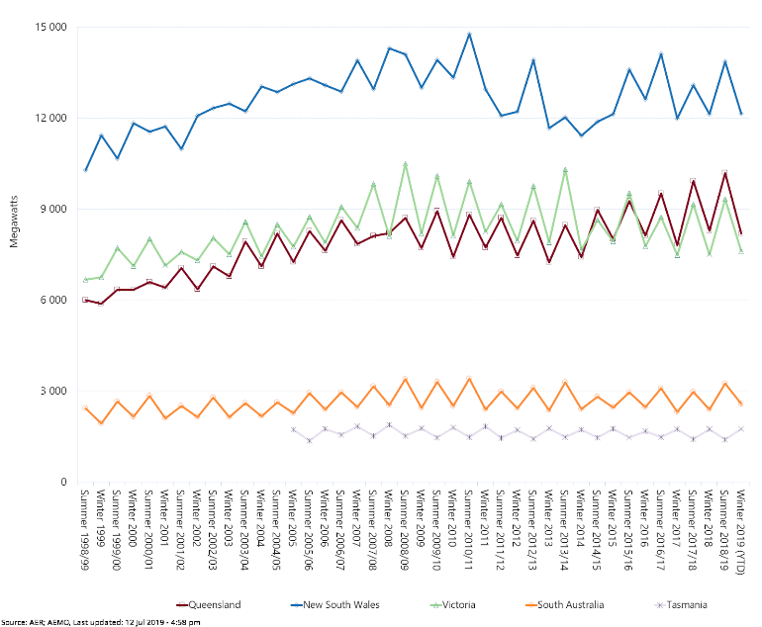

*Figure 5 – Electricity usage in Australia per season per state*

The graph found from the Australian Energy Regulator is revealing that the demand is higher in winter and in NSW. It is due to the lower temperature and shorter days, using both lights and heater. The use of electricity is further described by the graph below. The average household, on top of using more electricity in winter, will reach its peak consumption in the morning from 8am to 10am and in the evening from 6pm to 10pm.

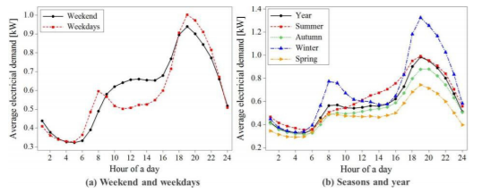

*Figure 6 – Electricity Demand per day per hour (Source: ScienceDirect)*

One important point is the need of an energy storage system in order to store energy when it is produced or not used. Wind turbines creates AC electricity and later converted to DC before being stored in batteries. This system is only designed to produce and store energy, while transmission to the household is not considered and a third-party company will need to be contacted.

In the case study, the author claims that using a Fuhrländer 250 turbine will grant us “an expected lifetime of 15 years” [5] (2004, Andrew Stiel and Maria Skyllas-Kazacos). In terms of size, the renewable energy systems will only need to provide electricity to around 350 households. As stated above, it will be assisting the existing energy source by providing and reducing the use of non-renewable energy. Thus, the system doesn’t have to be as rigorous in terms of producing the right amount of energy.

# Design System Topology

Considering the small size of the different targeted islands (1 km diameter approximately for Scotland Island), the distance from generation to consumption will relatively small. While solar panels can be installed per household, it is uncommon to have a wind energy system for a household. Constructing onshore might raise environmental issues, ruin the scenery and in turn raise complaints from the local. However, onshore center is preferred as maintenance will be easier and the distance until delivering energy will be shortened. An isolated area on the island will be needed to provide energy for the island as a whole. As isolated islands, the wind tends to be stronger and thus its lack will not be a worry. This renewable energy systems will assist and not replace the existing source and will consequently not be as vast as one might think.

Furthermore, horizontal axis wind turbine will be preferred over horizontal axis wind turbine. Even though horizontal axis wind turbine has “higher cost in tower construction to hold the generator, gearbox and the heavy blades” and they also “require additional control mechanism for controlling the direction of the turbine blades” [6] it has a better efficiency in converting wind to energy. For a medium scale converting energy to electricity for 350 households, a higher efficiency is needed in order to build less and smaller wind turbine with better capacity.

Calculated earlier, an approximate of 15,986 KWh/year will be needed to supply electricity to an average household, and 2,095,100 KWh/year for the whole island. As the wind turbine will be acting as a complement to the AC grid, there will be a need for energy storage system. The aim of this system is to provide at least 70% coverage for the island electricity consumption.

For the topology of this system, several other components will be needed, and more detailed descriptions are provided in this section.

On top of the turbine blades, a tail section is needed to allow the turbine to change its direction and face it towards the direction of the wind. Alternatively, the more modern wind turbines will use a Yaw drive and motor to change the direction of the turbine. It will also need a winch for the generator to be lowered if maintenance is needed.

As AC electricity is generated by the wind turbine, a rectifier is needed to convert AC to DC and store the energy to a battery storage system. The rectifier should be located in a separate control box.

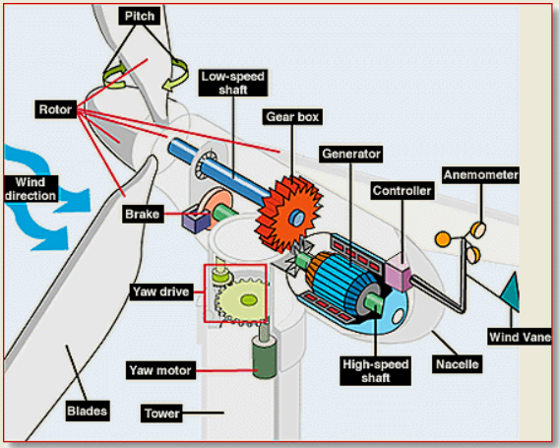

*Figure 7 – Wind turbines components (Source: NREL)*

In the diagram above, the different components in the wind turbine are listed. While the anemometer records the wind speed, it inputs the data to the controller that start the machine when a certain wind speed is reached and stops the system when the wind is too strong, avoiding permanent damage. The gearbox plays an important role in the wind turbine and connects the low and high-speed shaft. It supports and allows the high-speed shaft to reach a sufficient speed for the generator to produce electricity.

As mentioned earlier, the system will only produce and store the energy while transmission to each household will be handled by a third-party professional. The wind generator site will need several turbines in order to reach an adequate production of energy.

In the next section, more specific components will be discussed, and which one will be chosen.

# Design System Components

First, the size of the turbine must be determined before choosing which components can satisfy the requirements of the system. After careful calculations (shown in the next section), the size of each rotor will be 25 meters. For the wind turbines to operate without being affected or affecting the population and the environment, the lower part of the rotor must be elevated to at least 20 meters above ground. In this case, the turbines chosen will have a tower as tall as 35 meters.

# Evaluation of the system performance

To satisfy the needs of the population of Scotland Island, several calculations had to be processed. In fact, finding the right size of the blades of the turbines and how many wind turbines was needed was crucial to the development of this project. According to the European Wind Energy Association, “An average onshore wind turbine with a capacity of 2.5–3 MW can produce more than 6 million kWh in a year – enough to supply 1,500 average EU households with electricity” [7]. Finding the ratio between the capacity to the production of energy, we can determine the size of the wind blades. To find how much power a certain rated wind turbine produce every year, we do: 365 x24 x(wind turbine rating)x(efficiency). As 3MW rated wind turbine produces around 6 million KWh, the efficiency was found to be 0.22. After several trials and errors, we have come to find the appropriate rating of the wanted wind turbines and its number. It was settled that the system required four 200KW rated wind turbine. Using the equation above, each individual turbine will produce 438,000 KWh. Thus, the four turbines will be more than enough to cover more than 80% of Scotland Island yearly electricity consumption (1,752,000 KWh out of 2,095,100 KWh). Comparing different 200 KWh rated wind turbines, the average rotor diameter was 25-30m.

## Template

This document may be used as a template for preparing your Transactions/Journal paper. You may type over sections of the document, cut and paste into it, and/or use markup styles.

## Format

If you choose not to use this document as a template, prepare your technical work in single-spaced, double-column format, on paper 21.6×27.9 centimeters (8.5×11 inches or 51×66 picas). Set top and bottom margins to 16.9 millimeters (0.67 inch or 4 picas) and left and right margins to about 16.9 millimeters (0.67 inch or 4 picas). Do not violate margins (i.e., text, tables, figures, and equations may not extend into the margins). The column width is 88.9 millimeters (3.5 inches or 21 picas). The space between the two columns is 4.2 millimeters (0.17 inch or 1 pica). Paragraph indentation is 4.2 millimeters (0.17 inch or 1 pica). Use full justification. Use either one or two spaces between sections, and between text and tables or figures, to adjust the column length.

## Typefaces and Sizes

Use a proportional serif typeface such as Times Roman or Times New Roman and embed all fonts. Table I provides samples of the appropriate type sizes and styles to use.

## Section Headings

A primary section heading is enumerated by a Roman numeral followed by a period and is centered above the text. A primary heading should be in capital letters.

A secondary section heading is enumerated by a capital letter followed by a period and is flush left above the section. The first letter of each important word is capitalized and the heading is italicized.

A tertiary section heading is enumerated by an arabic numeral followed by a parenthesis. It is indented and is followed by a colon. The first letter of each important word is capitalized and the heading is italicized.

A quaternary section heading is rarely necessary, but is perfectly acceptable if required. It is enumerated by a lowercase letter followed by a parenthesis. It is indented and is followed by a colon. Only the first letter of the heading is capitalized and the heading is italicized.

TABLE I

Samples of Times Roman Type Sizes and Styles

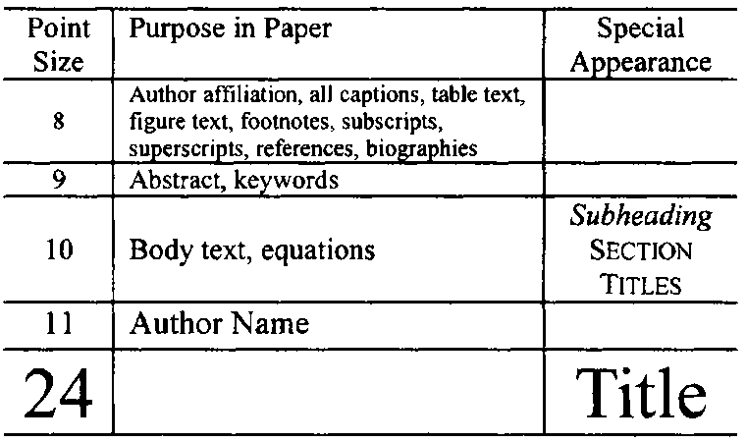

## Figures and Tables

Figure axis labels are often a source of confusion. Try to use words rather than symbols. As an example, write the quantity “Magnetization,” or “Magnetization, *M*,” not just “*M*.” Put units in parentheses. Do not label axes only with units. As in Fig. 1, write “Magnetization (kA/m)” or “Magnetization (kA·m-1),” not just “kA/m.” Do not label axes with a ratio of quantities and units. For example, write “Temperature (K),” not “Temperature/K.” Figure labels should be legible, approximately 8- to 10-point type.

The IEEE Graphics Analyzer Tool enables authors to pre-screen their graphics for compliance with IEEE Transactions and Journals standards before submission. The online tool is located at http://graphicsqc.ieee.org/.

To insert images in Microsoft Word, position the cursor at the insertion point and either use Insert | Picture | Insert Picture from File or copy the image to the Windows clipboard and then use Home | Paste | Paste Special | Picture. All figures and tables must be in place in the text near, but not before, where they are first mentioned.

Large figures and tables may span both columns, but may not extend into the page margins. Figure captions should be below the figures; table captions should be above the tables. Do not put captions in “text boxes” linked to the figures. Do not put borders around your figures. Use the abbreviation “Fig. 1,” even at the beginning of a sentence.

## Numbering

Number reference citations consecutively in square brackets [1]. The sentence punctuation follows the brackets [2]. Multiple references [2], [3] are each numbered with separate brackets [1]-[3]. Refer simply to the reference number, as in [3]. Do not use “Ref. [3]” or “reference [3]” except at the beginning of a sentence: “Reference [3] shows….”

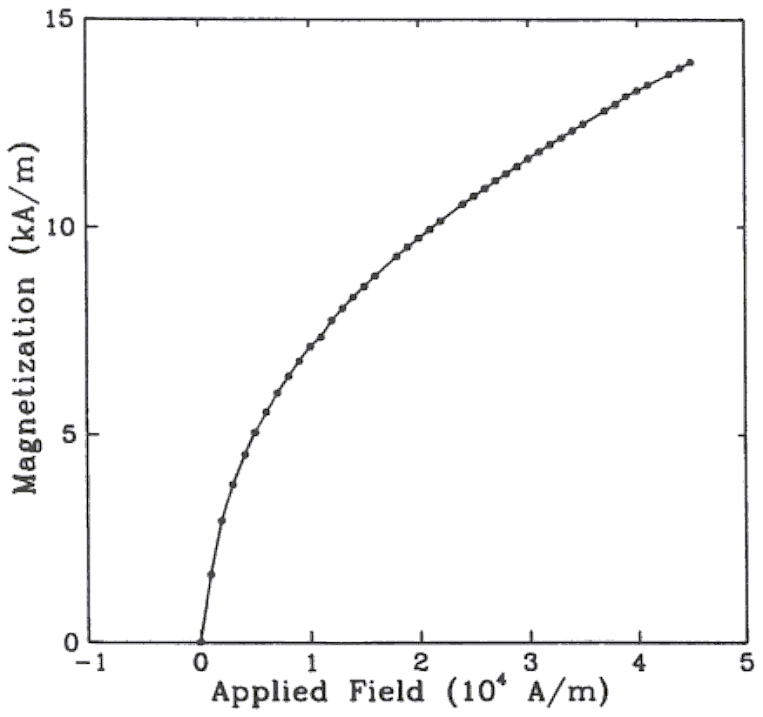

Fig. 1. Magnetization as a function of applied field. (Note that “Fig.” is abbreviated and there is a period after the figure number followed by two spaces.)

Number footnotes separately with superscripts (References | Insert Footnote). Place the actual footnote at the bottom of the column in which it is cited. Do not put footnotes in the reference list. Use letters for table footnotes.

Check that all figures and tables are numbered correctly. Use arabic numerals for figures and Roman numerals for tables.

Appendix figures and tables should be numbered consecutively with the figures and tables appearing in the rest of the paper. They should not have their own numbering system.

## Units

Metric units are preferred for use in IEEE publications in light of their global readership and the inherent convenience of these units in many fields. In particular, the use of the International System of Units (Systeme Internationale d'Unites or SI Units) is advocated. This system includes a subsystem of units based on the meter, kilogram, second, and ampere (MKSA). British units may be used as secondary units (in parentheses). An exception is when British units are used as identifiers in trade, such as 3.5-inch disk drive.

## Abbreviations and Acronyms

Define less common abbreviations and acronyms the first time they are used in the text, even after they have been defined in the abstract. Abbreviations such as IEEE, SI, MKS, CGS, ac, dc, and rms do not have to be defined. Do not use abbreviations in the title unless they are unavoidable.

See Appendix A of the Author’s Kit for additional information and standard abbreviations.

## Math and Equations

Use either the Microsoft Equation Editor or the *MathType* commercial add-on for MS Word for all math objects in your paper (Insert | Equation *or* MathType Equation).

To make your equations more compact, you may use the solidus ( / ), the exp function, or appropriate exponents. Italicize Roman symbols for quantities and variables, but not Greek symbols. Use a long dash rather than a hyphen for a minus sign. Use parentheses to avoid ambiguities in denominators.

Number equations consecutively with equation numbers in parentheses flush with the right margin, as in (1). Be sure that the symbols in your equation have been defined before the equation appears or immediately following.

where *IF* is the fault current.

Use “(1),” not “Eq. (1)” or “equation (1),” except at the beginning of a sentence: “Equation (1) is .…”

# Appendix

Appendixes, if needed, appear before the acknowledgment.

# Acknowledgment

The following is an example of an acknowledgment. (Please note that financial support should be acknowledged in the unnumbered footnote on the title page.)

The authors gratefully acknowledge the contributions of I. X. Austan, A. H. Burgmeyer, C. J. Essel, and S. H. Gold for their work on the original version of this document.

# References

References are important to the reader; therefore, each citation must be complete and correct. There is no editorial check on references; therefore, an incomplete or wrong reference will be published unless caught by a reviewer or discusser and will detract from the authority and value of the paper. References should be readily available publications.

List only one reference per reference number. If a reference is available from two sources, each should be listed as a separate reference. Give all authors' names; do not use *et al.*

Samples of the correct formats for various types of references are given below.

*Basic format for books:*

1. Vanya Walker-Leigh. (2012, September 24). Small Islands Push For New Energy, Our World. Online. Available: [https://ourworld.unu.edu/en/small-islands-push-for-new-energy](https://ourworld.unu.edu/en/small-islands-push-for-new-energyr)
2. Roger Rassool. (2013, November 11). Where does wind come from?. Cosmos. Online. Available: <https://cosmosmagazine.com/climate/where-does-wind-come>
3. New Jersey Institute of Technology’s Online Master of Science in Electrical Engineering. (2017, August). The most efficient form of renewable energy. Online. Available: <https://www.borntoengineer.com/efficient-form-renewable-energy>
4. Danish Wind Industry Association. (2003, May 18). Wind Speed Calculator. Online. Available: <http://xn--drmstrre-64ad.dk/wp-content/wind/miller/windpower%20web/en/tour/wres/calculat.htm>
5. Andrew Stiel, Mariah Skyllas-Kazacos. (2012, August 27). Feasibility Study of Energy Storage Systems in Wind/Diesel Applications using the HOMER model. Online. Available: <https://www.mdpi.com/2076-3417/2/4/726>
6. Kotb B. Tawfiq. (2019). Wind Energy Conversion System Topologies and Converters: Comparative reviews. Online. Available: <https://www.sciencedirect.com/science/article/pii/S1876610219313645>
7. European Wind Energy Association. (2016). Wind energy’s frequently asked questions. Online. Available: <http://www.ewea.org/wind-energy-basics/faq/>
8. J. K. Author, “Title of chapter in the book,” in *Title of His Published Book,* xth ed. City of Publisher, Country if not USA: Abbrev. of Publisher, year, ch. x, sec. x, pp. xxx–xxx.

*Examples:*

1. G. O. Young, “Synthetic structure of industrial plastics,” in *Plastics,* 2nd ed., vol. 3, J. Peters, Ed. New York: McGraw-Hill, 1964, pp. 15–64.
2. W.-K. Chen, *Linear Networks and Systems.* Belmont, CA: Wadsworth, 1993, pp. 123–135.

*Basic format for periodicals:*

1. J. K. Author, “Name of paper,” *Abbrev. Title of Periodical,* vol. x, no. x, pp. xxx–xxx, Abbrev. Month, year.

Examples:

1. J. U. Duncombe, “Infrared navigation—Part I: An assessment of feasibility,” *IEEE Trans. Electron Devices,* vol. ED-11, no. 1, pp. 34–39, Jan. 1959.
2. E. P. Wigner, “Theory of traveling-wave optical laser,” *Phys. Rev.,* vol. 134, pp. A635–A646, Dec. 1965.
3. E. H. Miller, “A note on reflector arrays,” *IEEE Trans. Antennas Propagat.,* to be published.

*Basic format for reports:*

1. J. K. Author, “Title of report,” Abbrev. Name of Co., City of Co., Abbrev. State, Rep. xxx, year.

*Examples:*

1. E. E. Reber, R. L. Michell, and C. J. Carter, “Oxygen absorption in the earth’s atmosphere,” Aerospace Corp., Los Angeles, CA, Tech. Rep. TR-0200 (4230-46)-3, Nov. 1988.
2. J. H. Davis and J. R. Cogdell, “Calibration program for the 16-foot antenna,” Elect. Eng. Res. Lab., Univ. Texas, Austin, Tech. Memo. NGL-006-69-3, Nov. 15, 1987.

*Basic format for handbooks:*

1. *Name of Manual/Handbook,* x ed., Abbrev. Name of Co., City of Co., Abbrev. State, year, pp. xxx–xxx.

*Examples:*

1. *Transmission Systems for Communications,* 3rd ed., Western Electric Co., Winston-Salem, NC, 1985, pp. 44–60.
2. *Motorola Semiconductor Data Manual,* Motorola Semiconductor Products Inc., Phoenix, AZ, 1989.

*Basic format for books (when available online):*

1. Author. (year, month day). *Title.* (edition) [Type of medium]. *volume (issue).* Available: site/path/file

*Example:*

1. J. Jones. (1991, May 10). *Networks.* (2nd ed.) [Online]. Available: http://www.atm.com

*Basic format for journals (when available online):*

1. Author. (year, month). Title. *Journal.* [Type of medium]. *volume (issue),* pages. Available: site/path/file

*Example:*

1. R. J. Vidmar. (1992, Aug.). On the use of atmospheric plasmas as electromagnetic reflectors. *IEEE Trans. Plasma Sci.* [Online]. *21(3),* pp. 876–880. Available: http://www.halcyon.com/pub/journals/21ps03-vidmar

*Basic format for papers presented at conferences (when available online):*

1. Author. (year, month). Title. Presented at Conference title. [Type of medium]. Available: site/path/file

*Example:*

1. PROCESS Corp., MA. Intranets: Internet technologies deployed behind the firewall for corporate productivity. Presented at INET96 Annual Meeting. [Online]. Available: http://home.process.com/Intranets/wp2.htp

*Basic format for reports and handbooks (when available online):*

1. Author. (year, month). Title. Company. City, State or Country. [Type of medium]. Available: site/path/file

*Example:*

1. S. L. Talleen. (1996, Apr.). The Intranet Architecture: Managing information in the new paradigm. Amdahl Corp., CA. [Online]. Available: http://www.amdahl.com/doc/products/bsg/intra/infra/html

*Basic format for computer programs and electronic documents (when available online):* ISO recommends that capitalization follow the accepted practice for the language or script in which the information is given.

*Example:*

1. A. Harriman. (1993, June). Compendium of genealogical software. *Humanist.* [Online]. Available e-mail: HUMANIST@NYVM.ORG Message: get GENEALOGY REPORT

*Basic format for patents (when available online):*

1. Name of the invention, by inventor’s name. (year, month day). *Patent Number* [Type of medium]. Available: site/path/file

*Example:*

1. Musical toothbrush with adjustable neck and mirror, by L. M. R. Brooks. (1992, May 19). *Patent D 326 189* [Online]. Available: NEXIS Library: LEXPAT File: DESIGN

*Basic format for conference proceedings (published):*

1. J. K. Author, “Title of paper,” in *Abbreviated Name of Conf.,* City of Conf., Abbrev. State (if given), year, pp. xxx–xxx.

*Example:*

1. D. B. Payne and J. R. Stern, “Wavelength-switched passively coupled single-mode optical network,” in *Proc. IOOC-ECOC,* 1985, pp. 585–590.

*Example for papers presented at conferences (unpublished):*

1. D. Ebehard and E. Voges, “Digital single sideband detection for interferometric sensors,” presented at the 2nd Int. Conf. Optical Fiber Sensors, Stuttgart, Germany, Jan. 2–5, 1984.

*Basic format for patents:*

1. J. K. Author, “Title of patent,” U.S. Patent x xxx xxx, Abbrev. Month, day, year.

*Example:*

1. G. Brandli and M. Dick, “Alternating current fed power supply,” U.S. Patent 4 084 217, Nov. 4, 1978.

*Basic format for theses (M.S.) and dissertations (Ph.D.):*

1. J. K. Author, “Title of thesis,” M.S. thesis, Abbrev. Dept., Abbrev. Univ., City of Univ., Abbrev. State, year.
2. J. K. Author, “Title of dissertation,” Ph.D. dissertation, Abbrev. Dept., Abbrev. Univ., City of Univ., Abbrev. State, year.

*Examples:*

1. J. O. Williams, “Narrow-band analyzer,” Ph.D. dissertation, Dept. Elect. Eng., Harvard Univ., Cambridge, MA, 1993.
2. N. Kawasaki, “Parametric study of thermal and chemical nonequilibrium nozzle flow,” M.S. thesis, Dept. Electron. Eng., Osaka Univ., Osaka, Japan, 1993.

*Basic format for the most common types of unpublished references:*

1. J. K. Author, private communication, Abbrev. Month, year.
2. J. K. Author, “Title of paper,” unpublished.
3. J. K. Author, “Title of paper,” to be published.

*Examples:*

1. A. Harrison, private communication, May 1995.
2. B. Smith, “An approach to graphs of linear forms,” unpublished.
3. A. Brahms, “Representation error for real numbers in binary computer arithmetic,” IEEE Computer Group Repository, Paper R-67-85.

*Basic format for standards:*

1. *Title of Standard,* Standard number, date.

*Examples:*

1. *IEEE Criteria for Class IE Electric Systems,* IEEE Standard 308, 1969.
2. *Letter Symbols for Quantities,* ANSI Standard Y10.5-1968.

# Biographies

A technical biography and photograph for each author may be included. The photo should be 2.54 centimeters (1 inch) wide by 3.18 centimeters (1.25 inches) high. The head and shoulders should be centered, and the photo should be flush with the left margin. The space required for the biographies and photos is included in the eight-page limit.

The first paragraph should begin with the author’s name (as it appears in the byline) and IEEE membership history. A place and/or date of birth may be included (list place, then date). Next, the author’s educational background is listed. The degrees should be listed with type of degree in what field, which institution, city, state, and country, and year the degree was earned. The author’s major field of study should be lower-cased.

The second paragraph uses the pronoun of the person (he or she) and not the author’s last name. It lists military and work experience, including summer and fellowship jobs. Job titles are capitalized. The current job must have a location; previous positions may be listed without one. Information concerning previous publications may be included. Try not to list more than three books or published articles. The format for listing publishers of a book within the biography is: title of book (city, state: publisher name, year) similar to a reference. Current and previous research interests end the paragraph.

The third paragraph begins with the author’s title and last name (e.g., Dr. Smith, Prof. Jones, Mr. Kajor, Ms. Hunter). List any memberships in professional societies other than the IEEE. Finally, list any awards and work for IEEE committees and publications.

The following is a biography of Nikola Tesla as an example.

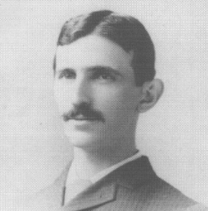**Nikola Tesla** (M’1888, F’17) was born in Smiljan in the Austro-Hungarian Empire, on July 9, 1856. He graduated from the Austrian Polytechnic School, Graz, and studied at the University of Prague.

His employment experience included the American Telephone Company, Budapest, the Edison Machine Works, Westinghouse Electric Company, and Nikola Tesla Laboratories. His special fields of interest included high frequency.

Dr. Tesla received honorary degrees from institutions of higher learning including Columbia University, Yale University, University of Belgrade, and the University of Zagreb. He received the Elliott Cresson Medal of the Franklin Institute and the Edison Medal of the IEEE. In 1956, the term “tesla” (T) was adopted as the unit of magnetic flux density in the MKSA system. In 1975, the Power Engineering Society established the Nikola Tesla Award in his honor. He died on January 7, 1943.

1. L. Tran is with the Electrical Engineering Department, University of Technology Sydney, New South Wales, Australia, a student studying Renewable Energy Systems.